Assignment-Digital Marketing

Name | VARUNSUNDAR A
RegNo | 962820106316
NM ID | 50A65EE108CBD65B6AE40E57613B053C

Blog link:https://varunthedesigner.design.blog/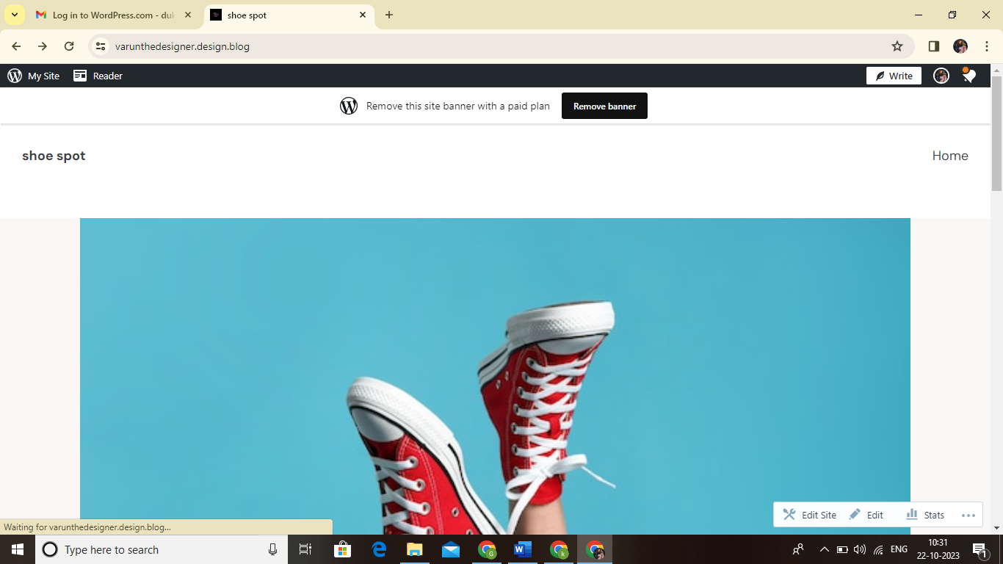
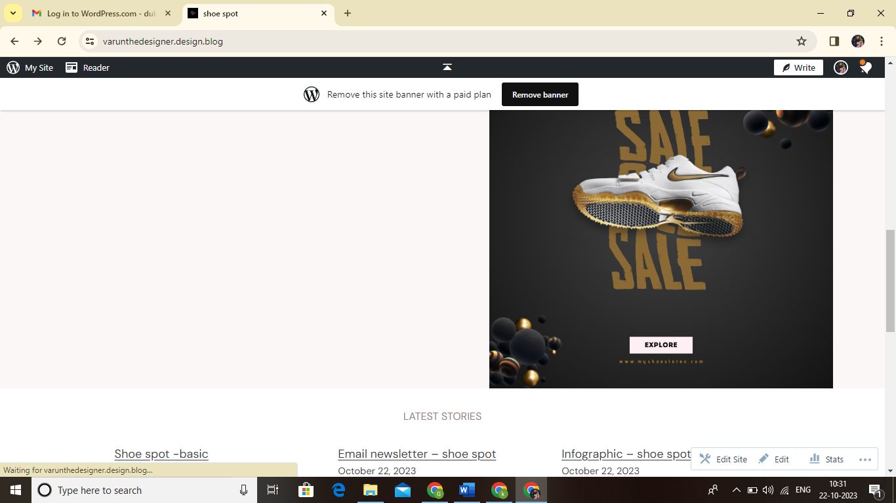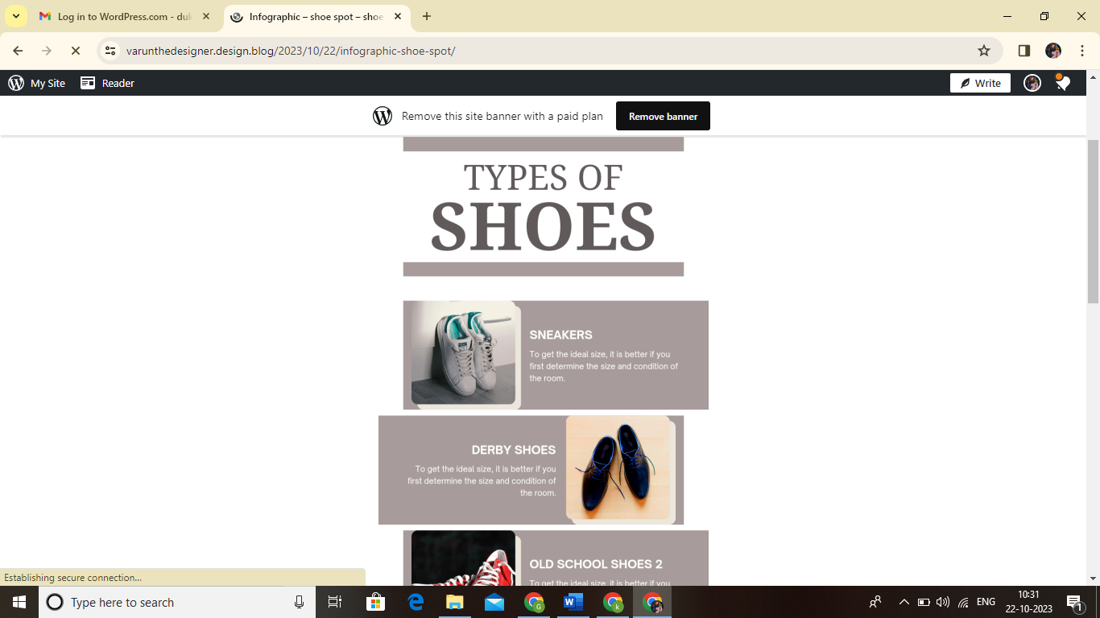

FaceBook Page link:https://www.facebook.com/ShoeSpot390
